[Super-Resolution using Deep Learning](../Desktop/1706.09077.pdf)

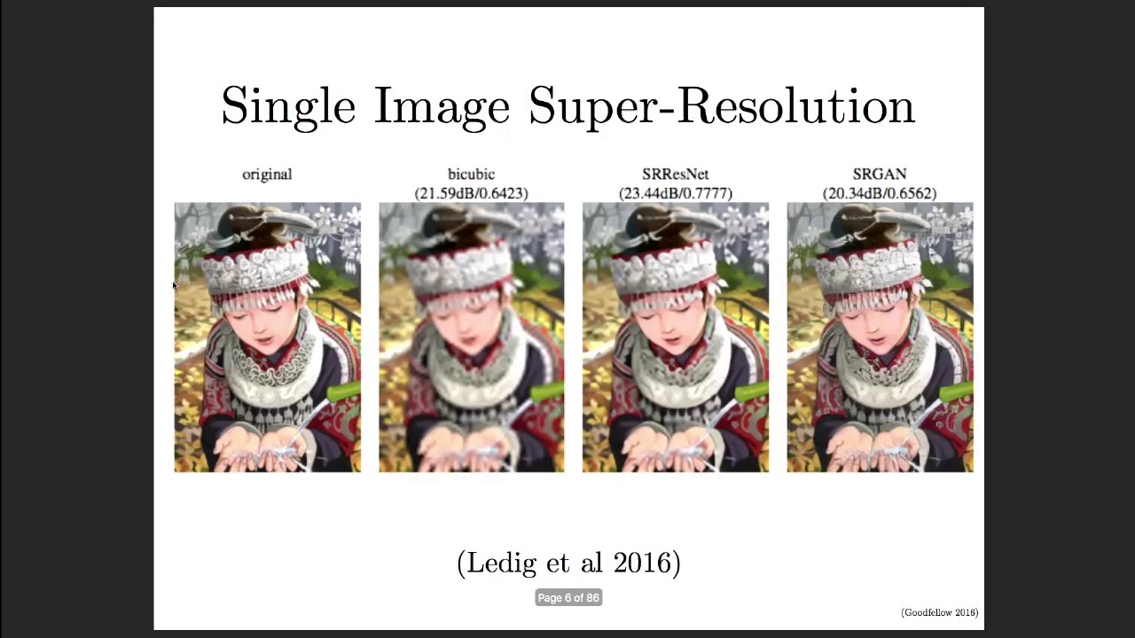

Final Project: INFO 7374 Special Topics in Info Systems – Sec 01, Spring 2018, Cognitive Computing

04.09.2018

Harsh Modi

Trupti Gore

Overview:

Super-resolution is the estimation of a High-resolution image/video from one or more low resolution observation of the same scene, using digital image processing and ML techniques. There are 3 tier classifications – Single Input Single Output (SISO), Multiple Input Single Output(MISO) and Multiple Input Multiple Output (MIMO). MIMO is used in video Super resolution, which can be merged with MISO, making SISO redundant. Hence, most often, classification is done in two categories - Single Input Super Resolution and Multiple Image or multi-frame super-resolution.

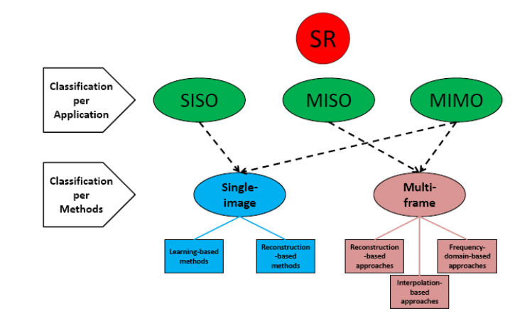

The Single Input Single Resolution (SISR) called Super Resolution CNN(SRCNN) is when we introduce large filters and additional mapping layers as very deep CNN between the Low Resolution and High Resolution.

Objective:

We aim to use Low Resolution images as input images to our network and get a High-Resolution Image as the output.

Dataset:

We plan to use the [CelebA](http://mmlab.ie.cuhk.edu.hk/projects/CelebA.html) dataset. This dataset is a large-scale face attributes dataset with more than 200k celebrity images. Images in this dataset cover large pose variations and background clutter. are currently in the process of finalizing a dataset for our analysis. We will first build the model for some Low-Resolution images to validate the output as expected (High Resolution). From the variety of face images in this dataset, we resort to using ‘aligned & cropped’ images dataset. We intend to use the 16x16 image to make it to High resolution (4x times) which is 64x64 pixels using GANs.

Steps to be followed:

1. We will use different models described in the research paper “Super resolution using Deep Learning” as our generator.
2. For discriminator we can use a pre-trained large matching model as we only need discriminator to be able to match the image in available dataset. It won’t matter if the generator is only matching
3. After training the GANs created with different architectures we’ll record the accuracy and convergence information for each used more.
4. We’ll use this information to create best GAN that we possibly can in time of two week.
5. As a measure of performance, we’ll use convergence of generator and discriminator as a base. Then we’ll take ability of the generator to generate any image from test data set which resembles the actual High-resolution image in consideration. So, if the generator can properly generate a high-resolution image matching the original high-resolution image which it has not seen ever before then we’ll consider it a success.

Project Coverage plan:

In first week, we’ll decide and implement top 3 models from the current paper as generator and decide what discriminator to use.

In the second week, we’ll tune our GAN and compare and analyze of all 3 GAN that we create.

We’ll deliver a final analytical report of what we’re able to achieve in the GAN setting and what future improvements we can do.

Particulars:

Programming Language used: **Python**

Tool Used: **Jupyter Notebook**

Cloud Tools: **Amazon Web Services EC2**

Optional additional platform: **Google Cloud Platform**

References and Resources:

<https://arxiv.org/pdf/1706.09077>